EXPERIMENT NO. 04
IMPLEMENTATION AND ANALYSIS OF LOGICAL EXPRESSIONS USING STATIC CMOS
―――――――――――――――――――――――――――――――――――――――――――――――――――――――
AIM
To implement and analyze Boolean logical expressions Y = (A + BC)' and Y = [(A + B) * C]' using static CMOS design style in LT Spice.
SOFTWARE USED
LT Spice
CIRCUIT DIAGRAM
General complementary CMOS logic gate structure:
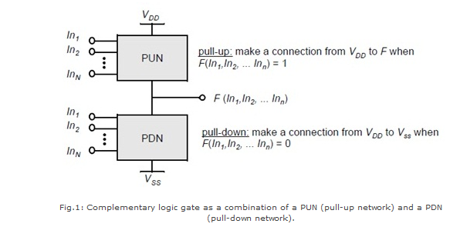
Figure 4.1: Complementary Static CMOS Architecture (PUN and PDN)
LT Spice circuit schematics for both Boolean expressions:
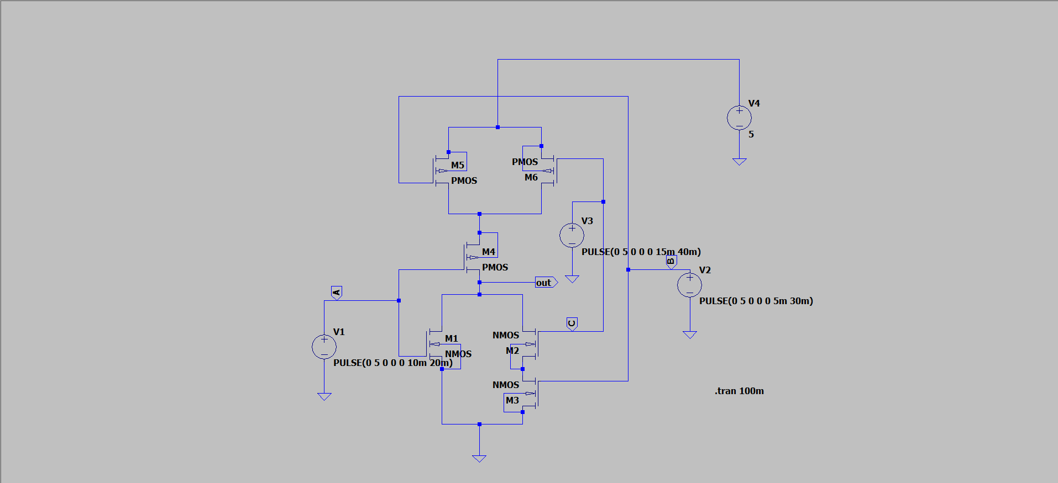
Figure 4.2: Circuit Schematic for Y = (A + BC)'
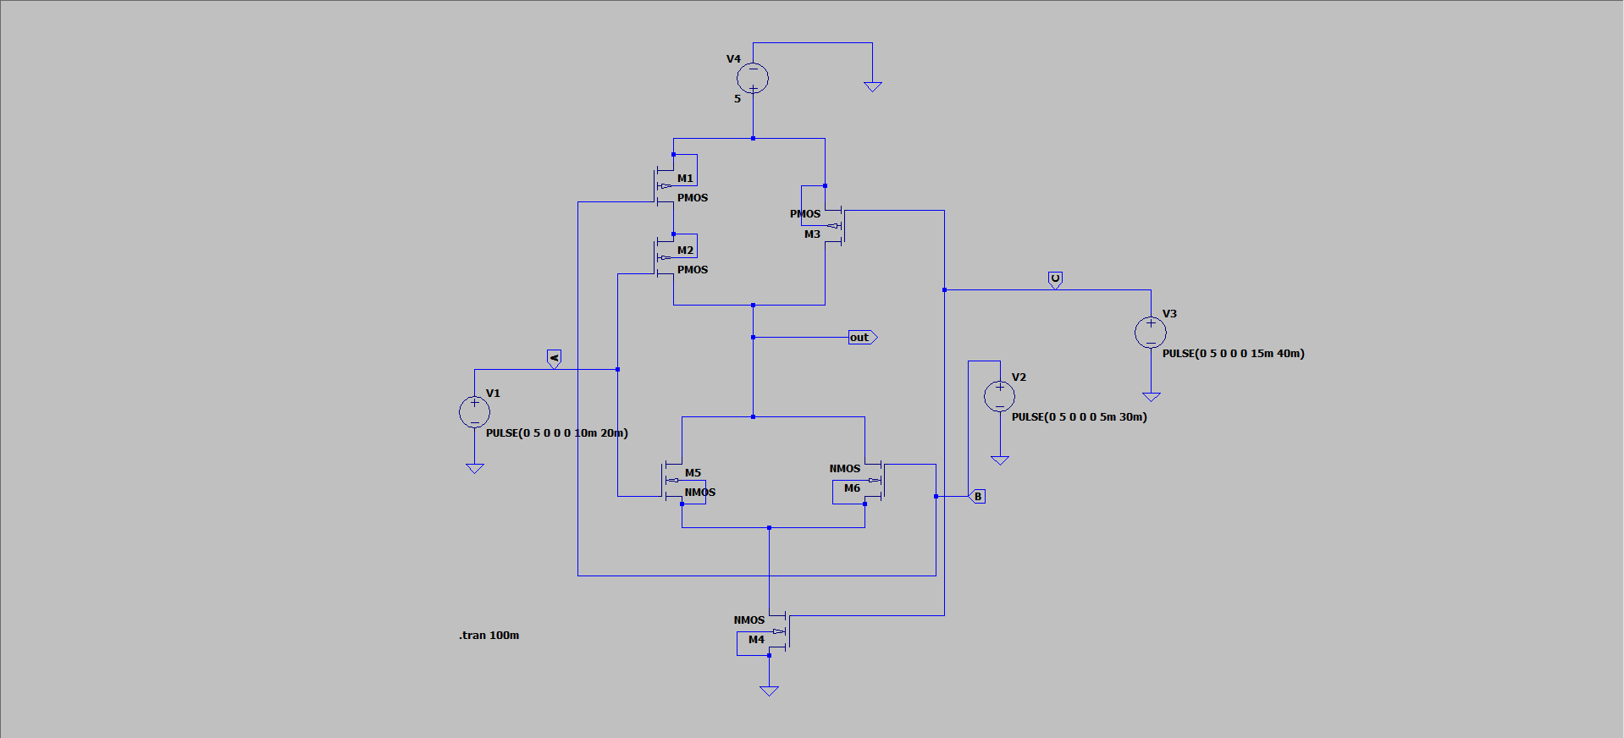
Figure 4.3: Circuit Schematic for Y = [(A + B) * C]'
SMALL THEORY
Static CMOS logic circuits are structured using two dual networks: a Pull-Up Network (PUN) composed of PMOS transistors connected to VDD, and a Pull-Down Network (PDN) composed of NMOS transistors connected to VSS. The PUN conducts when the logic function evaluates to 1, while the PDN conducts when the function evaluates to 0. Both networks operate in a mutually exclusive manner.
- Series/Parallel Rules: AND operation in PDN corresponds to NMOS devices connected in series, and in PUN corresponds to PMOS devices connected in parallel.
- OR operation in PDN corresponds to NMOS devices connected in parallel, and in PUN corresponds to PMOS devices connected in series.
Truth Table for Expression 1: Y = (A + BC)'
A | B | C | B·C | A + BC | (A + BC)'
0 | 0 | 0 | 0 | 0 | 1
0 | 0 | 1 | 0 | 0 | 1
0 | 1 | 0 | 0 | 0 | 1
0 | 1 | 1 | 1 | 1 | 0
1 | 0 | 0 | 0 | 1 | 0
1 | 0 | 1 | 0 | 1 | 0
1 | 1 | 0 | 0 | 1 | 0
1 | 1 | 1 | 1 | 1 | 0

Truth Table for Expression 2: Y = [(A + B) * C]'
A | B | C | A + B | (A + B)·C | [(A + B) * C]'
0 | 0 | 0 | 0 | 0 | 1
0 | 0 | 1 | 0 | 0 | 1
0 | 1 | 0 | 1 | 0 | 1
0 | 1 | 1 | 1 | 1 | 0
1 | 0 | 0 | 1 | 0 | 1
1 | 0 | 1 | 1 | 1 | 0
1 | 1 | 0 | 1 | 0 | 1
1 | 1 | 1 | 1 | 1 | 0

OUTPUT GRAPH
Transient output waveforms verified in LT Spice:
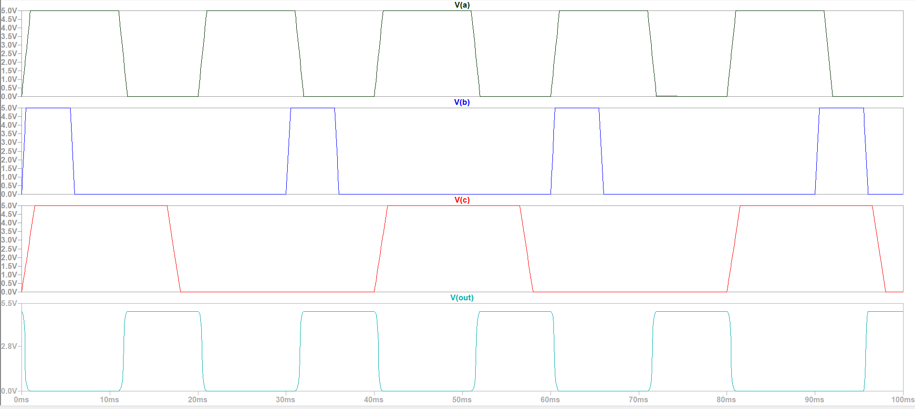
Figure 4.4: Simulation Waveform for Y = (A + BC)'
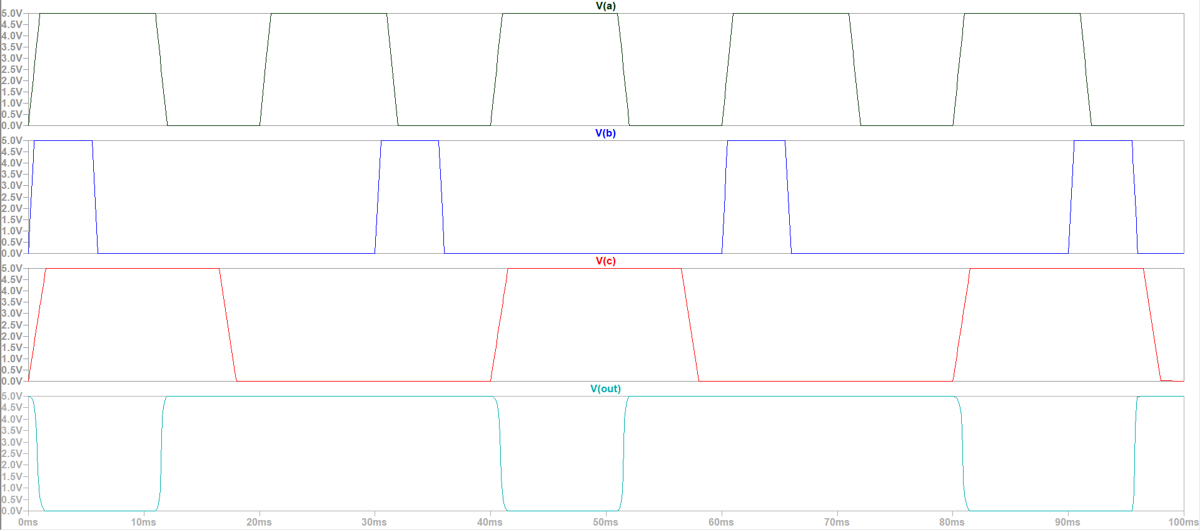
Figure 4.5: Simulation Waveform for Y = [(A + B) * C]'

